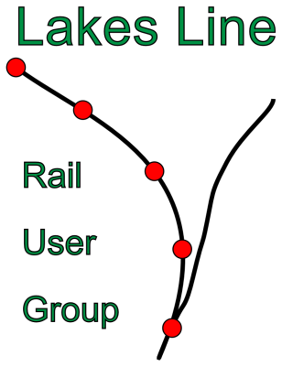
March 2016

Winter passenger survey
On 3rd February the Rail User Group carried out its annual low-season count of passengers using the Lakes Line. Volunteers travelled on all the trains of the day apart from the 06:21 from Oxenholme, counting the numbers of people who used the trains. The total was slightly down on the 2015 number, but very little. Last year’s figure showed an increase of 37% since the current timetable pattern came in in 2009, this year’s just 32%.
The volunteers would like to thank all the TransPennine Express (TPE) conductors who made us very welcome on the trains.

New franchises
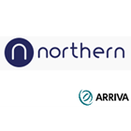
The February survey was the last to be conducted while TPE is the franchisee for the Lakes Line. From April 1st, there will be a new operator in charge, Arriva Rail North, which won the new Northern franchise. Under the new franchise, the Lakes Line was transferred from the Trans Pennine to the Northern franchise. There won’t be any immediate change to the timetable, though there will be some changes from 15th May. Initially at least we should see the same trains on the line, but changes to both the TPE and Northern Rail fleets may lead to changes between Oxenholme and Windermere.
On April 1st the new TransPennine Express franchise will take over running the services between Manchester and Scotland. Though the name may be the same, the company is new since it is now wholly owned by First Group, as its partner Keolis decided to bid separately for the new franchise. Again, expect to see the present trains still in use at first.

Both the new franchisees have promised big improvements both in the trains they will operate and the journey opportunities they offer. However, the timetable change in December 2017 is the earliest we shall see major changes, and the much heralded ‘Northern Connect’ network will not be fully operational till 2019.

